**MINOR PROJECT**

**Name:** Divyansh Verma

**Batch:** February (2023)

**Project:** Historical Places in India

* Screenshot of Code  
    
  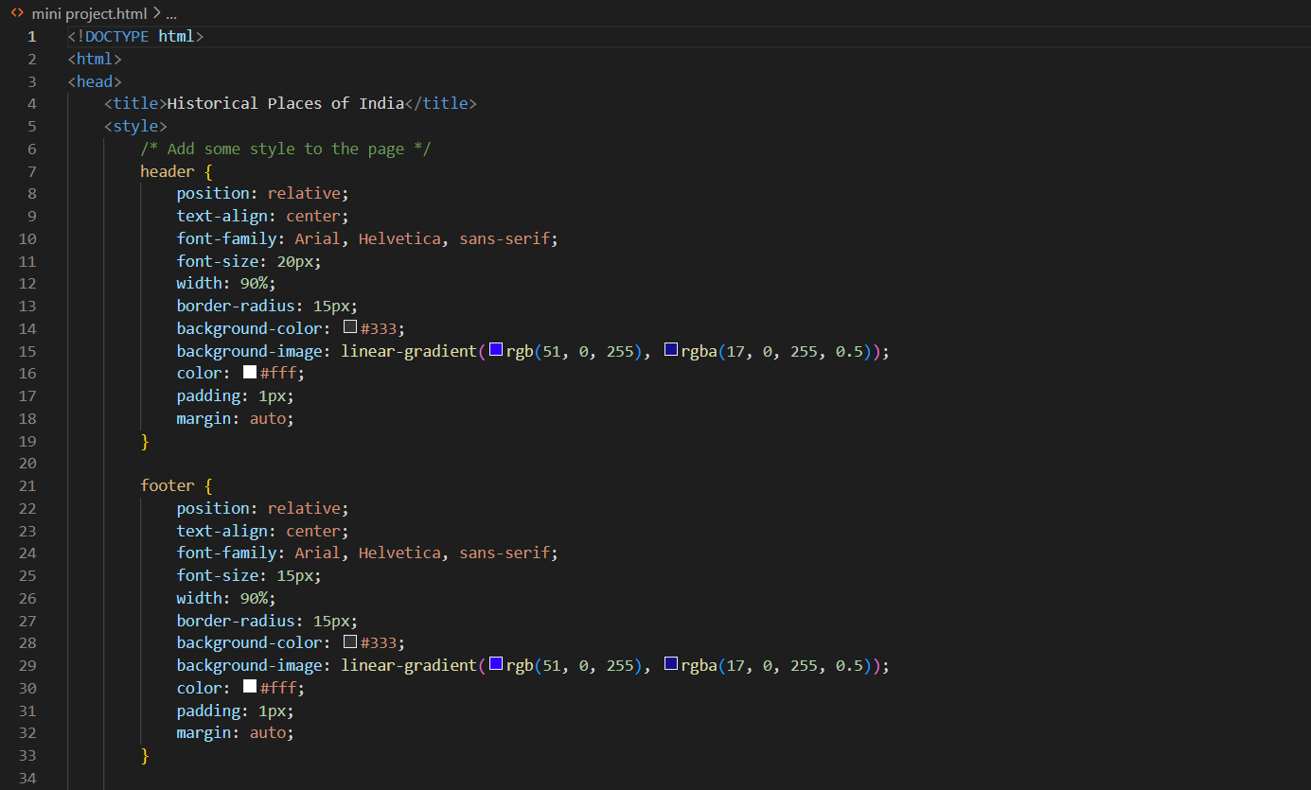  
    
  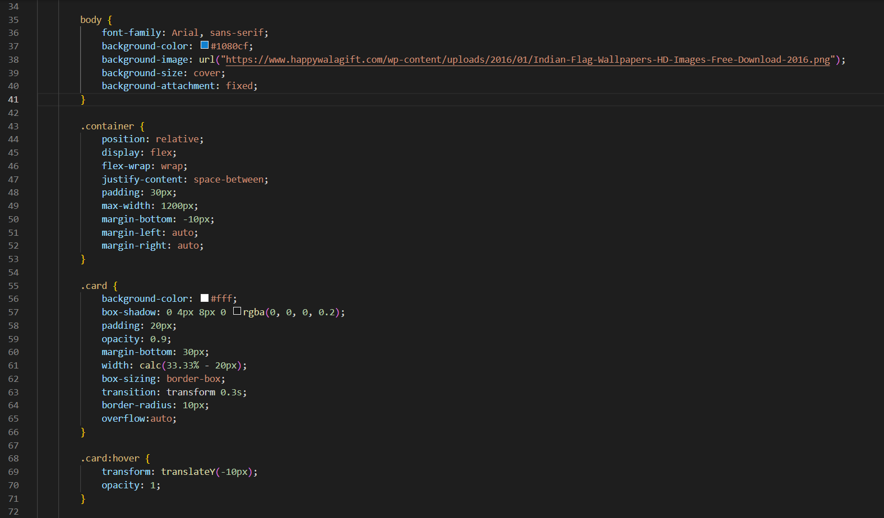  
    
  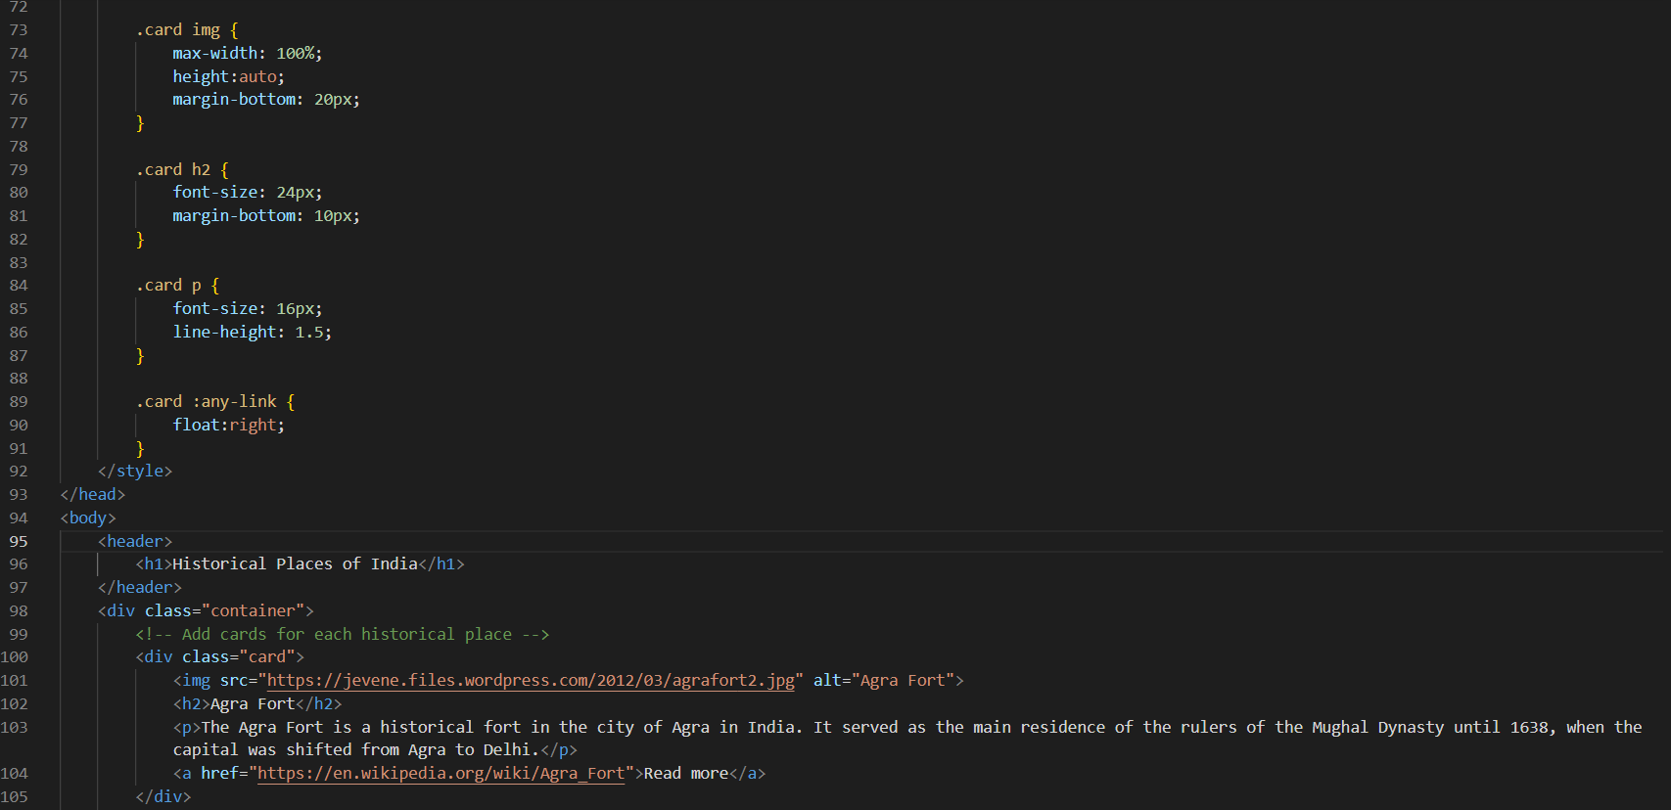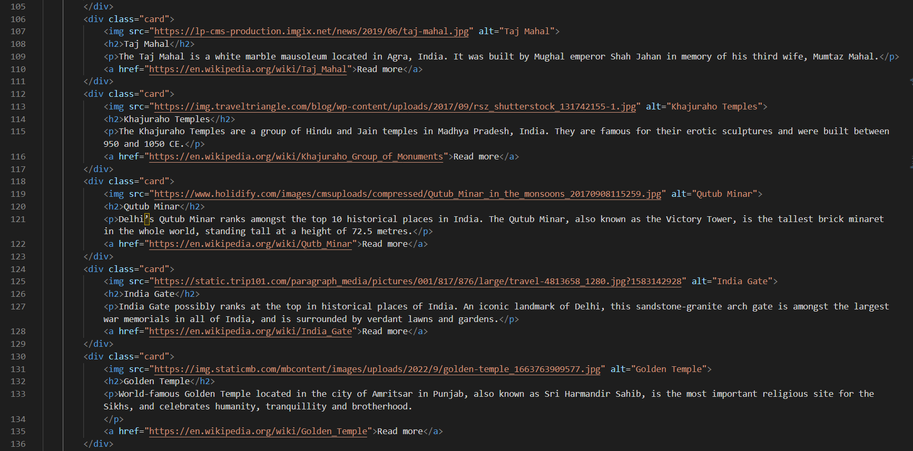  
    
  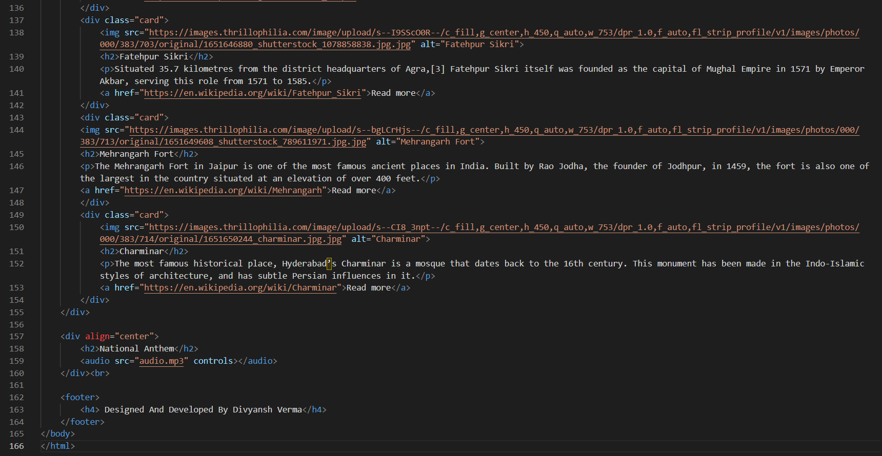
* Code

Code  
  
<!DOCTYPE html>

<html>

<head>

    <title>Historical Places of India</title>

    <style>

        /* Add some style to the page */

        header {

            position: relative;

            text-align: center;

            font-family: Arial, Helvetica, sans-serif;

            font-size: 20px;

            width: 90%;

            border-radius: 15px;

            background-color: #333;

            background-image: linear-gradient(rgb(51, 0, 255), rgba(17, 0, 255, 0.5));

            color: #fff;

            padding: 1px;

            margin: auto;

        }

        footer {

            position: relative;

            text-align: center;

            font-family: Arial, Helvetica, sans-serif;

            font-size: 15px;

            width: 90%;

            border-radius: 15px;

            background-color: #333;

            background-image: linear-gradient(rgb(51, 0, 255), rgba(17, 0, 255, 0.5));

            color: #fff;

            padding: 1px;

            margin: auto;

        }

        body {

            font-family: Arial, sans-serif;

            background-color: #1080cf;

            background-image: url("https://www.happywalagift.com/wp-content/uploads/2016/01/Indian-Flag-Wallpapers-HD-Images-Free-Download-2016.png");

            background-size: cover;

            background-attachment: fixed;

        }

        .container {

            position: relative;

            display: flex;

            flex-wrap: wrap;

            justify-content: space-between;

            padding: 30px;

            max-width: 1200px;

            margin-bottom: -10px;

            margin-left: auto;

            margin-right: auto;

        }

        .card {

            background-color: #fff;

            box-shadow: 0 4px 8px 0 rgba(0, 0, 0, 0.2);

            padding: 20px;

            opacity: 0.9;

            margin-bottom: 30px;

            width: calc(33.33% - 20px);

            box-sizing: border-box;

            transition: transform 0.3s;

            border-radius: 10px;

            overflow:auto;

        }

        .card:hover {

            transform: translateY(-10px);

            opacity: 1;

        }

        .card img {

            max-width: 100%;

            height:auto;

            margin-bottom: 20px;

        }

        .card h2 {

            font-size: 24px;

            margin-bottom: 10px;

        }

        .card p {

            font-size: 16px;

            line-height: 1.5;

        }

        .card :any-link {

            float:right;

        }

    </style>

</head>

<body>

    <header>

        <h1>Historical Places of India</h1>

    </header>

    <div class="container">

        <!-- Add cards for each historical place -->

        <div class="card">

            <img src="https://jevene.files.wordpress.com/2012/03/agrafort2.jpg" alt="Agra Fort">

            <h2>Agra Fort</h2>

            <p>The Agra Fort is a historical fort in the city of Agra in India. It served as the main residence of the rulers of the Mughal Dynasty until 1638, when the capital was shifted from Agra to Delhi.</p>

            <a href="https://en.wikipedia.org/wiki/Agra_Fort">Read more</a>

        </div>

        <div class="card">

            <img src="https://lp-cms-production.imgix.net/news/2019/06/taj-mahal.jpg" alt="Taj Mahal">

            <h2>Taj Mahal</h2>

            <p>The Taj Mahal is a white marble mausoleum located in Agra, India. It was built by Mughal emperor Shah Jahan in memory of his third wife, Mumtaz Mahal.</p>

            <a href="https://en.wikipedia.org/wiki/Taj_Mahal">Read more</a>

        </div>

        <div class="card">

            <img src="https://img.traveltriangle.com/blog/wp-content/uploads/2017/09/rsz_shutterstock_131742155-1.jpg" alt="Khajuraho Temples">

            <h2>Khajuraho Temples</h2>

            <p>The Khajuraho Temples are a group of Hindu and Jain temples in Madhya Pradesh, India. They are famous for their erotic sculptures and were built between 950 and 1050 CE.</p>

            <a href="https://en.wikipedia.org/wiki/Khajuraho_Group_of_Monuments">Read more</a>

        </div>

        <div class="card">

            <img src="https://www.holidify.com/images/cmsuploads/compressed/Qutub_Minar_in_the_monsoons_20170908115259.jpg" alt="Qutub Minar">

            <h2>Qutub Minar</h2>

            <p>Delhi’s Qutub Minar ranks amongst the top 10 historical places in India. The Qutub Minar, also known as the Victory Tower, is the tallest brick minaret in the whole world, standing tall at a height of 72.5 metres.</p>

            <a href="https://en.wikipedia.org/wiki/Qutb_Minar">Read more</a>

        </div>

        <div class="card">

            <img src="https://static.trip101.com/paragraph_media/pictures/001/817/876/large/travel-4813658_1280.jpg?1583142928" alt="India Gate">

            <h2>India Gate</h2>

            <p>India Gate possibly ranks at the top in historical places of India. An iconic landmark of Delhi, this sandstone-granite arch gate is amongst the largest war memorials in all of India, and is surrounded by verdant lawns and gardens.</p>

            <a href="https://en.wikipedia.org/wiki/India_Gate">Read more</a>

        </div>

        <div class="card">

            <img src="https://img.staticmb.com/mbcontent/images/uploads/2022/9/golden-temple_1663763909577.jpg" alt="Golden Temple">

            <h2>Golden Temple</h2>

            <p>World-famous Golden Temple located in the city of Amritsar in Punjab, also known as Sri Harmandir Sahib, is the most important religious site for the Sikhs, and celebrates humanity, tranquillity and brotherhood.

            </p>

            <a href="https://en.wikipedia.org/wiki/Golden_Temple">Read more</a>

        </div>

        <div class="card">

            <img src="https://images.thrillophilia.com/image/upload/s--I9SScO0R--/c_fill,g_center,h_450,q_auto,w_753/dpr_1.0,f_auto,fl_strip_profile/v1/images/photos/000/383/703/original/1651646880_shutterstock_1078858838.jpg.jpg" alt="Fatehpur Sikri">

            <h2>Fatehpur Sikri</h2>

            <p>Situated 35.7 kilometres from the district headquarters of Agra,[3] Fatehpur Sikri itself was founded as the capital of Mughal Empire in 1571 by Emperor Akbar, serving this role from 1571 to 1585.</p>

            <a href="https://en.wikipedia.org/wiki/Fatehpur_Sikri">Read more</a>

        </div>

        <div class="card">

        <img src="https://images.thrillophilia.com/image/upload/s--bgLCrHjs--/c_fill,g_center,h_450,q_auto,w_753/dpr_1.0,f_auto,fl_strip_profile/v1/images/photos/000/383/713/original/1651649608_shutterstock_789611971.jpg.jpg" alt="Mehrangarh Fort">

        <h2>Mehrangarh Fort</h2>

        <p>The Mehrangarh Fort in Jaipur is one of the most famous ancient places in India. Built by Rao Jodha, the founder of Jodhpur, in 1459, the fort is also one of the largest in the country situated at an elevation of over 400 feet.</p>

        <a href="https://en.wikipedia.org/wiki/Mehrangarh">Read more</a>

        </div>

        <div class="card">

            <img src="https://images.thrillophilia.com/image/upload/s--CI8_3npt--/c_fill,g_center,h_450,q_auto,w_753/dpr_1.0,f_auto,fl_strip_profile/v1/images/photos/000/383/714/original/1651650244_charminar.jpg.jpg" alt="Charminar">

            <h2>Charminar</h2>

            <p>The most famous historical place, Hyderabad’s Charminar is a mosque that dates back to the 16th century. This monument has been made in the Indo-Islamic styles of architecture, and has subtle Persian influences in it.</p>

            <a href="https://en.wikipedia.org/wiki/Charminar">Read more</a>

        </div>

    </div>

    <div align="center">

        <h2>National Anthem</h2>

        <audio src="audio.mp3" controls></audio>

    </div><br>

    <footer>

        <h4> Designed And Developed By Divyansh Verma</h4>

    </footer>

</body>

</html>

* Screenshot of Webpage  
    
  